SOLUTIONS

Important Terms

Solvent –

Solute –

ELECTROLYTES

* Substances
* These ions can conduct
* Examples:

SOLUBILITY

* Is the amount
* “Like dissolves Like”

SOLUBILITY RULES

1. All common salts of Group I elements and ammonium are soluble
2. All common acetates and nitrates are soluble
3. All binary compounds of Group 7 (other than F) with metals are soluble except those of silver, mercury I and lead
4. All sulfates are soluble except those of barium, strontium, calcium, silver, mercury I and lead
5. Except for those in Rule 1, carbonates, hydroxides, oxides, sulfides and phosphates are insoluble

Terms

* Saturated
* Unsaturated
* Supersaturated
* Concentrated
* Dilute

Factors Affecting the Rate of Dissolution

* Surface Area
* Stirring
* Temperature

Temperature vs Solubility

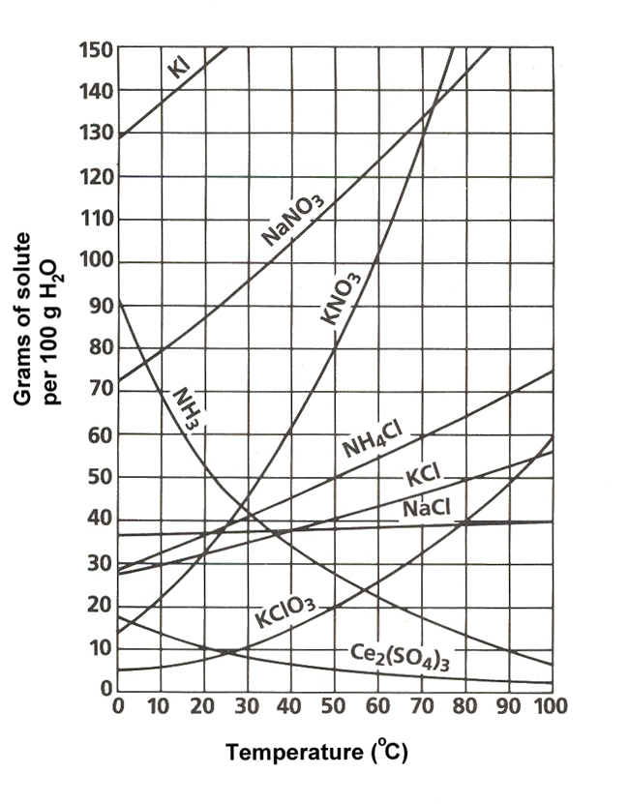

MOLARITY

Molarity-

M =

Example:

Calculate the molarity of a solution prepared by dissolving 11.5 g of NaOH in enough water to make a 1.50 L solution.

Example:

Calculate the molarity of a solution prepared by dissolving 1.56 g of HCl into enough water to make 26.8 ml of solution.

DILUTIONS

* Example:
* What volume of 16 M sulfuric acid must be used to prepare 1.5 L of a 0.10 M H2SO4
* Example:
* `What volume of 12 M HCl must be used to prepare 0.75 L of a 0.25 M HCl?

MASS PERCENT

* A unit of concentration equal to the mass of solute per mass of solution

part x 100

whole

* Example:

A solution is prepared by mixing 1.00 g of ethanol with 100.0 g of water. Calculate the mass percent of ethanol in this solution.

* Example:bg

A 135 g sample of seawater is evaporated to dryness, leaving 4.73 g of salt. Calculate the mass percent of salt in the saltwater.